Module 10

Assignment 10.2
Course: CSD402-340A Java for Programmers
Prepared By: Mirach Erkol
Date of Report: 2/21/2025

https://mikey5007.github.io/biosite/
10.2 Assignment: Landing Page
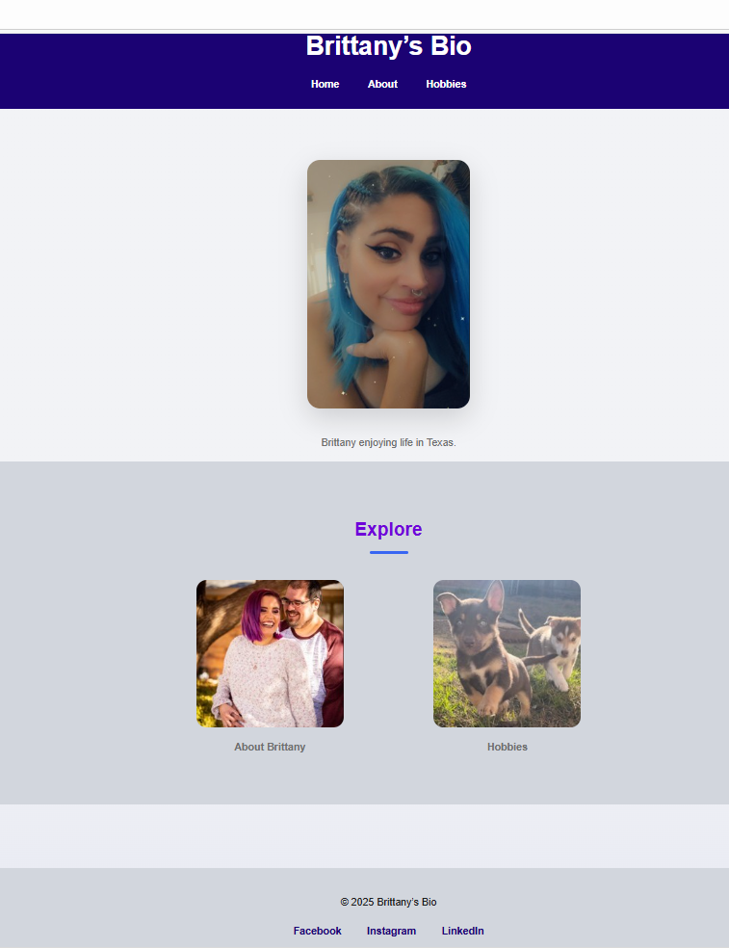
10.2 Assignment: About Page
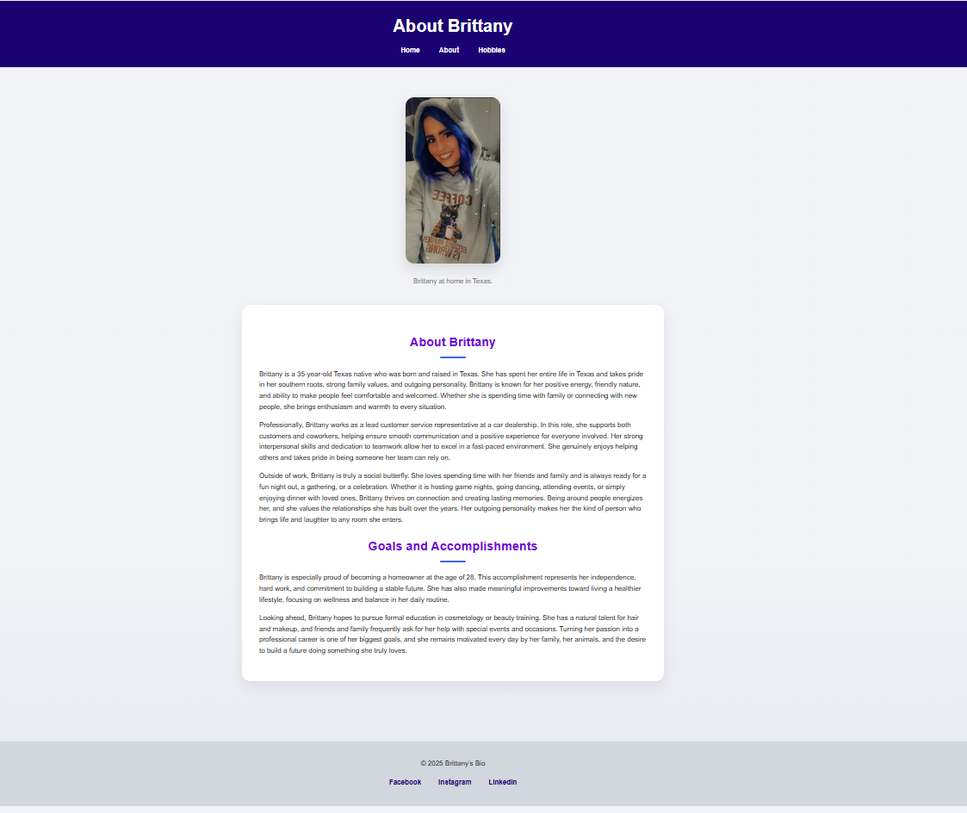

10.2 Assignment: Hobbies Page
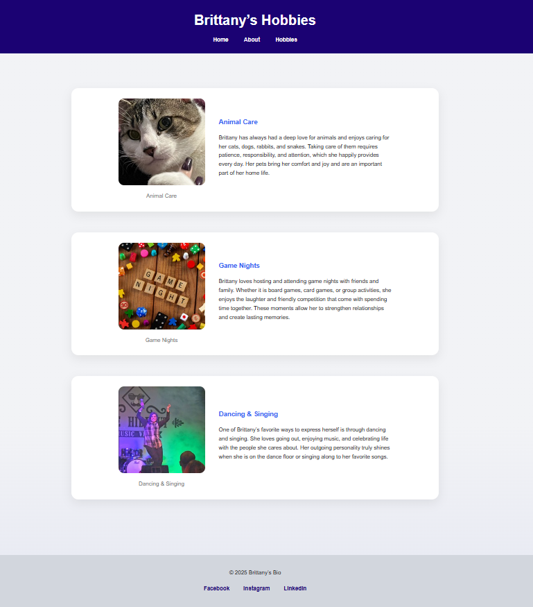
References:

https://github.com/Mikey5007/biosite.git
https://mikey5007.github.io/biosite/

